Some simple preprocessing of the data will be required before it is ready for use. We can do this in Weka:
From the Preprocess (default) tab in Weka, hit Open file... and select the
spambase.arff file that you downloaded above.
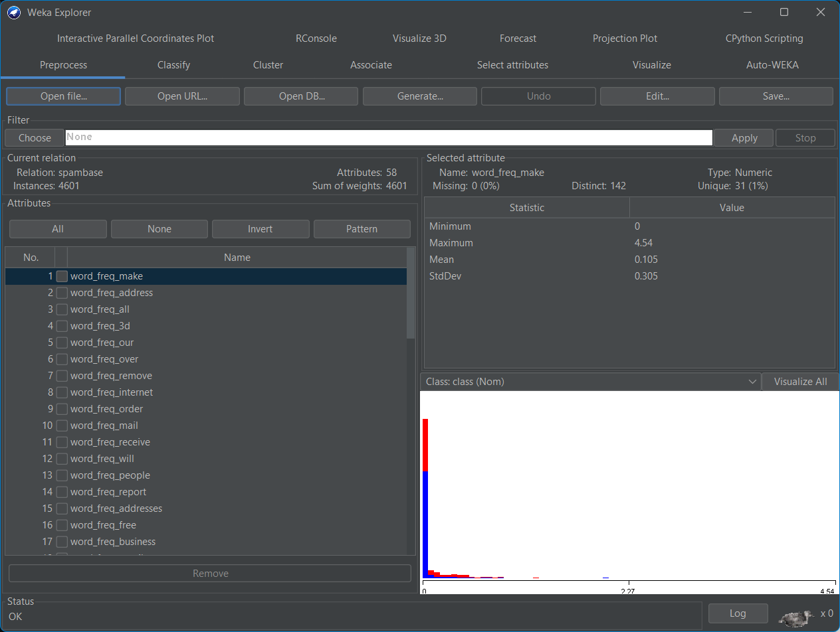
Delete the capital_run_length_average, capital_run_length_longest and
capital_run_length_total attributes by checking the box to their left and
hitting the Remove button.
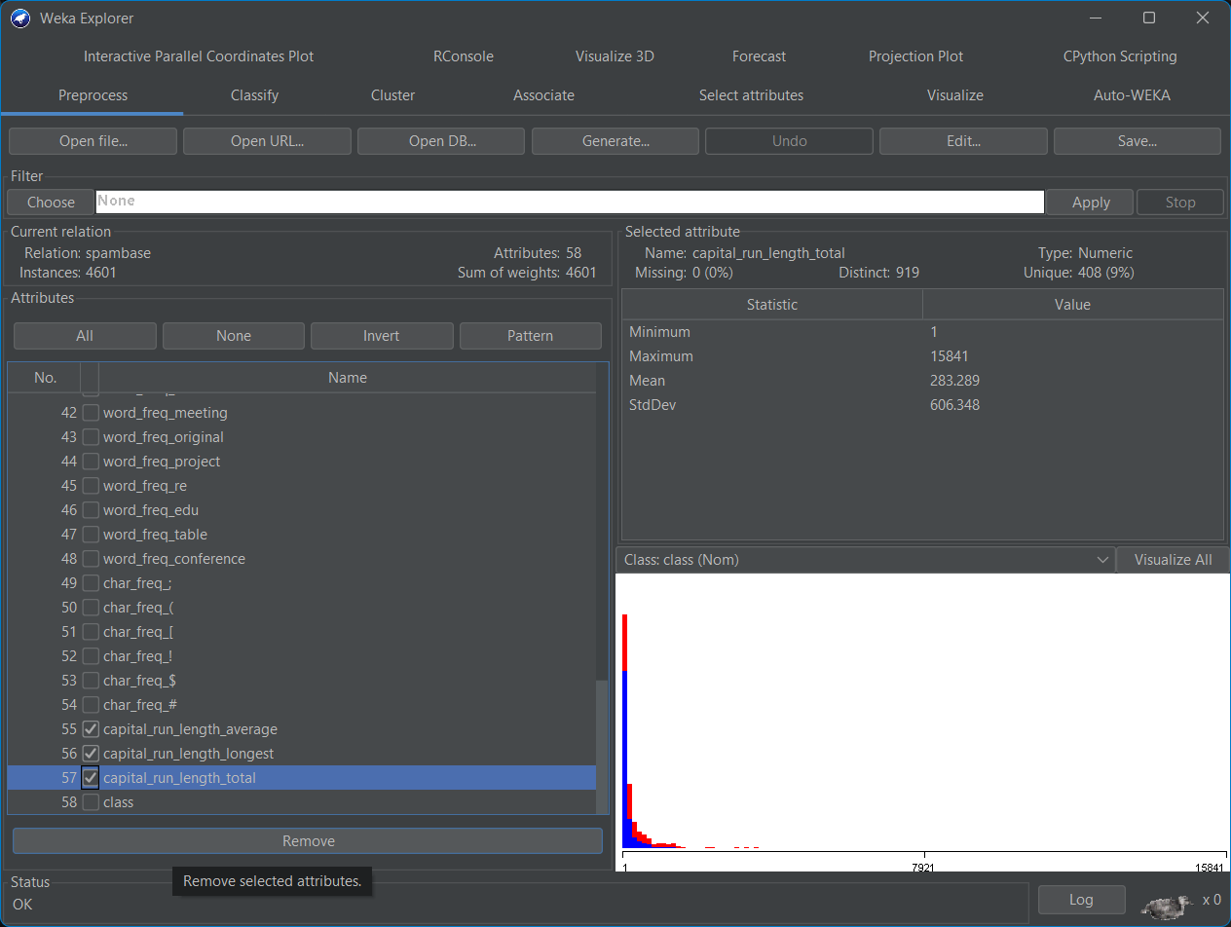
We wish to convert these to Boolean values instead: 1 if the word or character is present in the email, 0 if not. To do this, select the Choose button in the Filter frame at the top of the window, and pick filters > unsupervised > attribute > NumericToBinary. Now hit the Apply button. All the numeric frequency attributes are now converted to Booleans. Each e-mail is now represented by a 55 dimensional vector representing whether or not a particular word exists in an e-mail.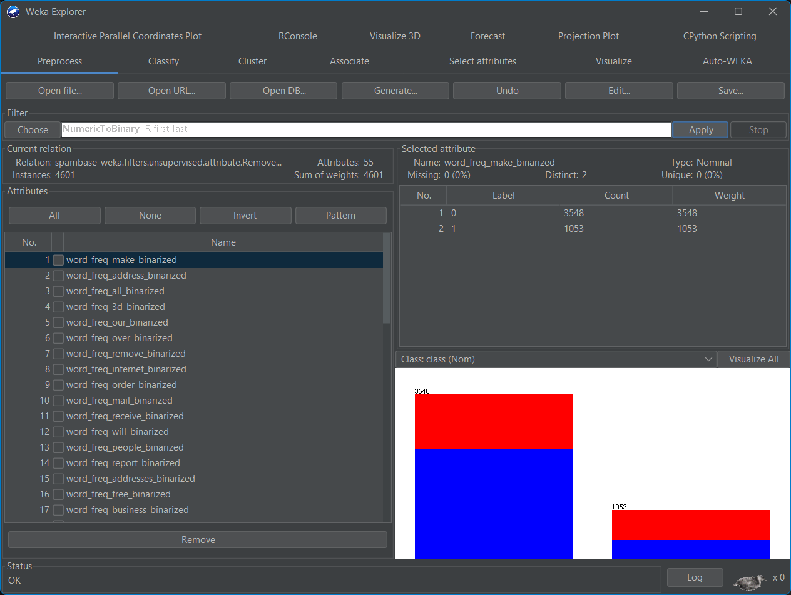
Save this preprocessed data set for future use using the Save... button.
You will need this for lab 2.
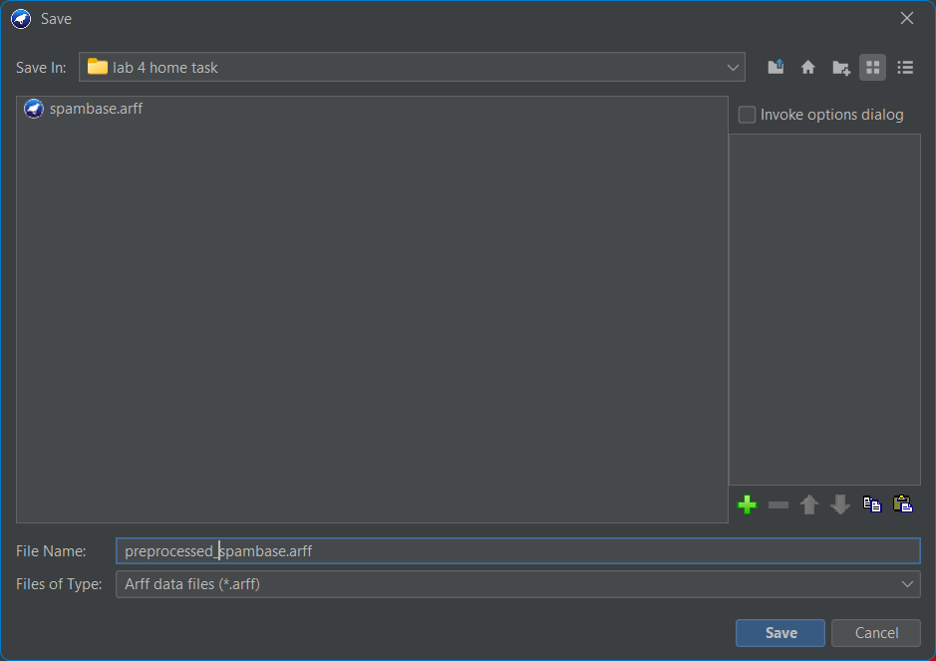

Given the data set we’ve just loaded, we wish to train a Naïve Bayes classifier to distinguish spam from regular email by fitting a distribution of the number of occurrences of each word for all the spam and non-spam e-mails. Under the Classify tab:
Select Choose in the Classifier frame at the top and select classifiers > bayes > NaiveBayes
Leave the default settings and hit Start to build the classifier. Study the output produced, most importantly the percentages of correctly and incorrectly classified instances. You probably will notice that your classifer does rather well despite making a very strong assumption on the form of the data.
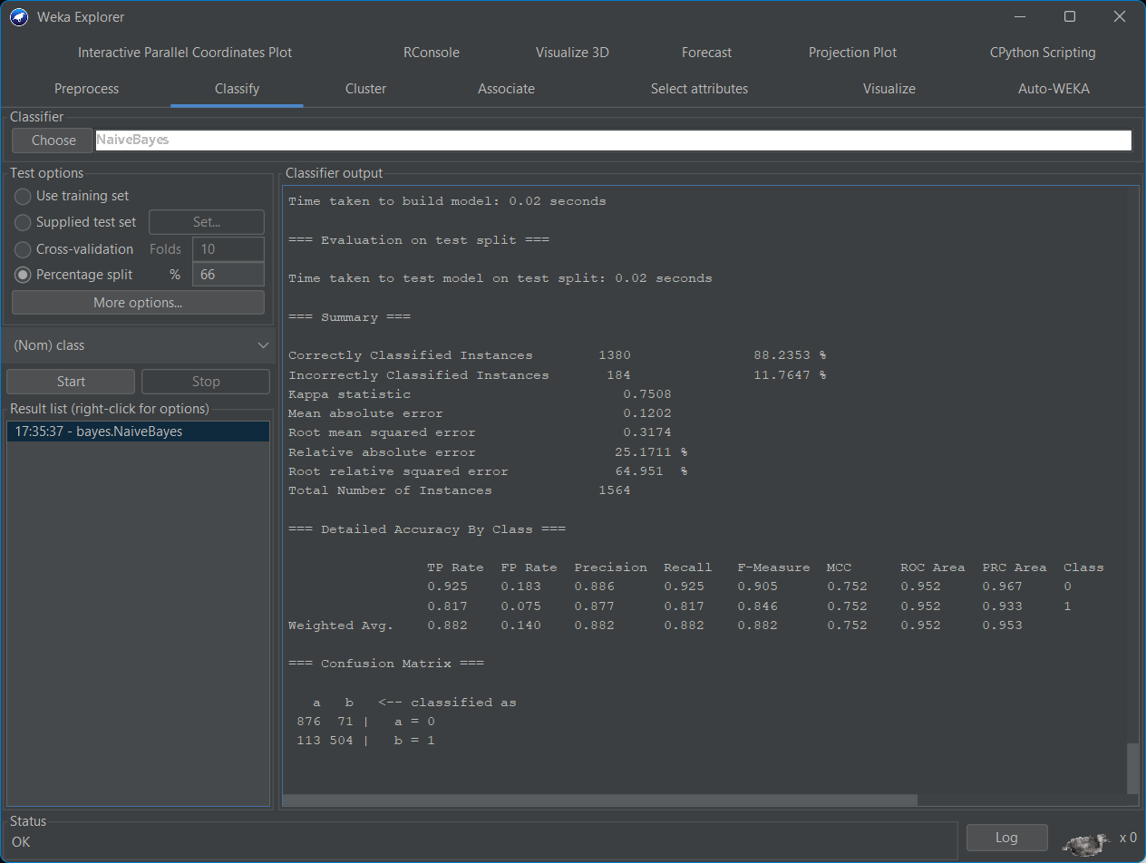
- Can you come up with a reason for the good performance? The good performance of the Naive Bayes classifier is its simplicity and the fact that it assumes that all features are independent of each other.
- What would be the main practical problems we would face if we were not to make this assumption for this particular dataset? If we were not to make this assumption, we might face issues such as increased computational complexity and overfitting, especially if the dataset has a large number of features.
- How long did your classifer take to train and classify? the classifier took 0.02 seconds to train and classify, which is quite fast.
- Given this, how scalable do you think the Naïve Bayes classifier is to large datasets? Naive Bayes classifier is highly scalable to large datasets. Our dataset had 4601 instances
- Can you come up with a good reason for this? The reason for this is its simplicity and the fact that it treats each feature independently. This means that the computation for each feature can be done separately and then combined, which is a process that can be easily parallelized for large datasets.
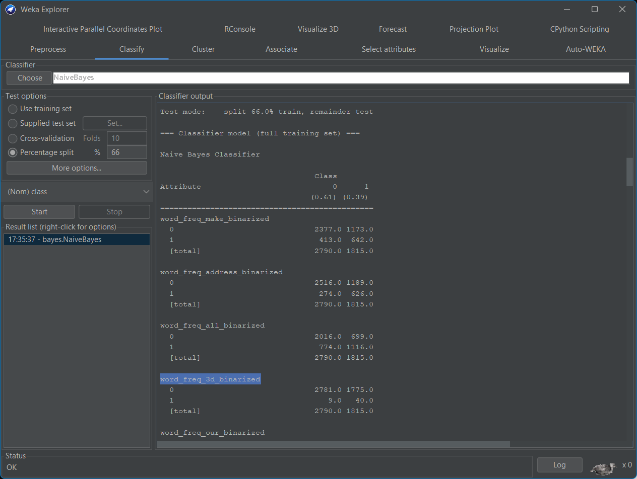
Examine the classifier models produced by Weka (printed above the performance summary). Find the prior probabilities for each class. The prior probabilities for each class can be found in the Weka output. For class 0 (non-spam), the prior probability is 0.61 and for class 1 (spam), it is 0.39.
• How does Naïve Bayes compute the probability of an e-mail belonging to a class (spam/not spam)? The Naive Bayes classifier computes the probability of an email belonging to a class (spam/not spam) by applying Bayes' theorem. It calculates the prior probabilities for each class (spam/not spam) and the likelihood of observing the features given the class. The class with the highest posterior probability is then chosen as the prediction.
• Compute the conditional probability of observing the word "3d" given that an e-mail is spam P(3d|spam) and that it is non-spam P(3d|non-spam).
To compute the conditional probability of observing the word "3d" given that an email is spam (P(3d|spam)) and non-spam (P(3d|non-spam)), we can use the counts provided in the Weka output.
- For P(3d|spam), we divide the count of spam emails containing "3d" by the total count of spam emails. From the Weka output, this would be 40/1815 = 0.022.
- For P(3d|non-spam), we divide the count of non-spam emails containing "3d" by the total count of non-spam emails. From the Weka output, this would be 9/2790 = 0.003.

For the final part of this section we will now pretend we are spammers wishing to fool a spam checking system based on Naïve Bayes into classifying a spam e-mail as ham (i.e. a valid e-mail). We will now use all of the training data to train our classifier and apply the learnt classifer to a dedicated test set. Load the test set in Weka. Under the Classify tab, select supplied test set > set > open file and set the test file to the supplied spambase_test.arff.
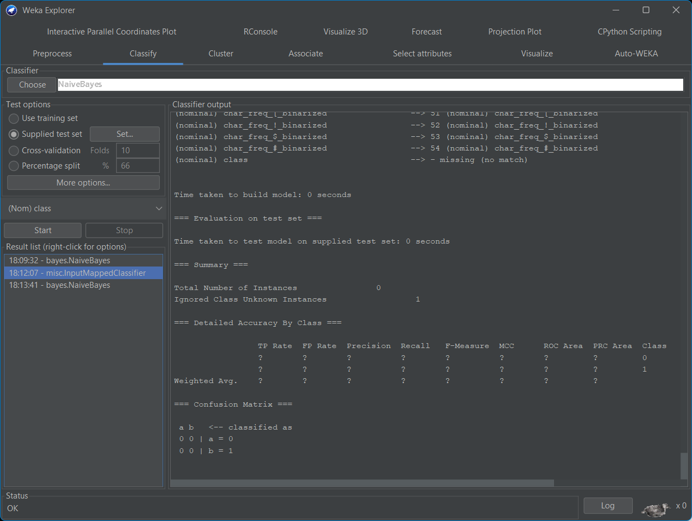
Does the classifer classify the spam e-mail correctly? NO, as it needs all labels/attrbutes to match
During testing, Weka will ignore this attribute and will instead use our previously trained classifier to predict the class label of this e-mail. Re-run the classifer on the modified test set. Has the class label (spam/non-spam) for this e-mail changed?
We had to rename the “is_spam” attribute to “class” for the test set to run.
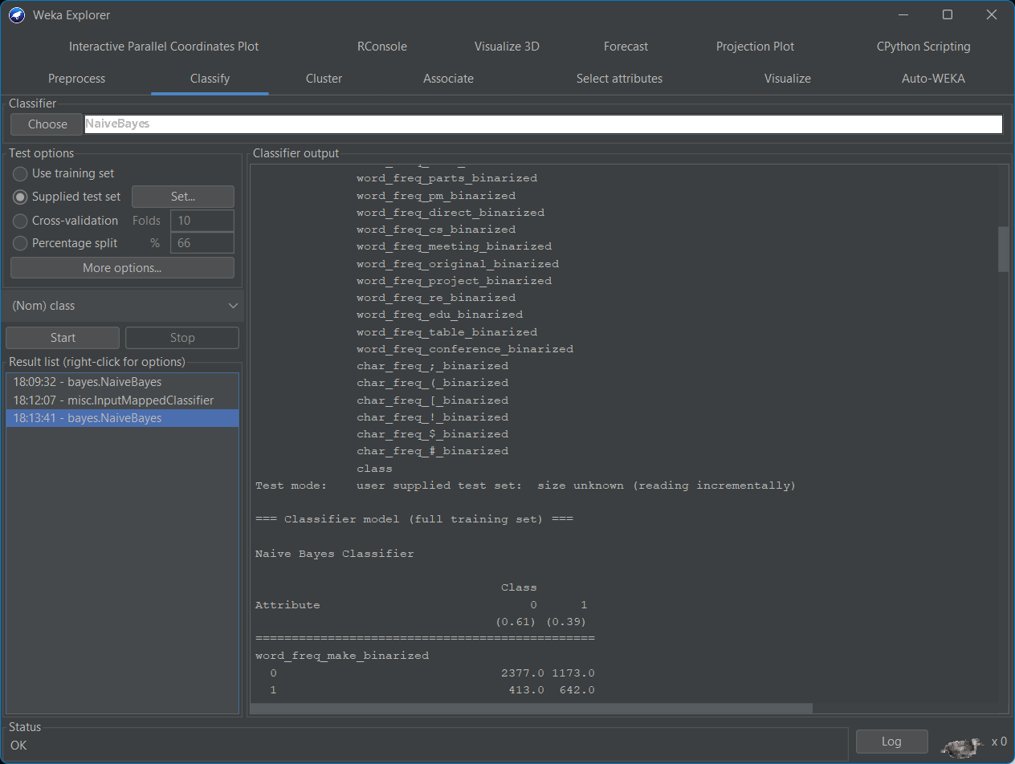
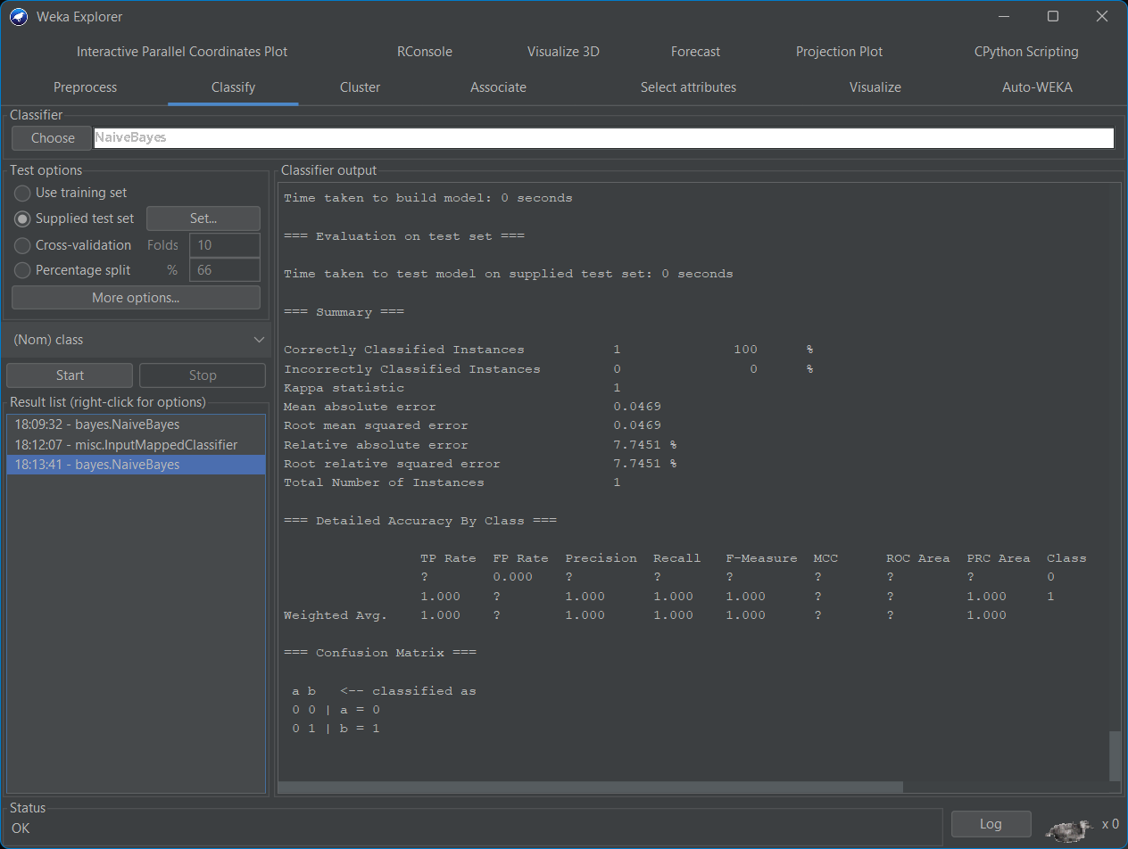
Yes it has changed

